IT2654 Systems Administration & Security

Tutorial 10

Discuss within your groups and prepare the answers to be presented in class.

- Figure 1 shows the output of ls -l. Describe the various columns numbered 1 to 7. How do you tell if it’s a file or directory?

- (2) (3) (4) (5) (6) (7)
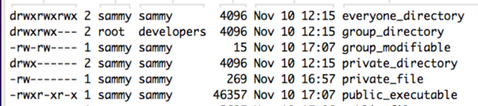
- Object type + file permission
- No. of links
- User owner
- Group owner
- Size in bytes
- Date of last modified
- Object name
File or directory 1st character: d=directory; - dash = file
- A user (student) created a directory called apple and a file called banana.out. The ls -l command displayed the following:

drwxrwxr-x. 2 student student 4096 Jul 4 23:31 apple
-rw-rw-r--. 1 student student 0 Jul 4 23:33 banana.out

- What is the default permission of a directory?
User owner = rwx
Group owner = rwx
Others = rx
- What is the default permission of a file?
User = rw
Group = rw
Others = r
- Who are their owner and group?
User = group = student

- Write the chmod commands in both Absolute/Numeric and Symbolic modes to change apple and banana.out to the following outcome. What do the permission mean to the different categories of users?

- drwxrwxrwx. 2 student student 4096 Jul 4 23:31 apple

chmod 777 apple
chmod ugo = rwx apple
chmod a=rwx apple

symbols: u = user, g = group, o = others, a = all (ugo), rwx, + - =

- drwxrwx---. 2 student student 4096 Jul 4 23:31 apple
chmod 770 apple
chmod ug = rwx, o= apple
chmod ug=rwx, o-rwx apple

r=4, w=2, x=1

- -rw-rw-rw-. 1 student student 0 Jul 4 23:33 banana.out
chmod 666 banana.out
chmod a=rw banana.out
chmod ugo=rw banana.out

- -rw-r-----. 1 student student 0 Jul 4 23:33 banana.out
chmod 640 banana.out
chmod u=rw, g=r, o= banana.out

- What is the purpose of setuid? How is it implemented (in numeric and symbolic modes)? Use the following to help explain your answer:

-rwsr-xr-x. 1 root root 30768 Feb 17 2012 /usr/bin/passwd
s shows you that it is a setuid
Executable = passwd
It will run with the owner’s privilege (owner = root)

- What is the purpose of setgid? How is it implemented (in numeric and symbolic modes)? Use the following to help explain your answer:

Before: drwxrwxr-x. 2 root manager 4096 Jul 4 06:12 korea/
After: drwxrwsr-x. 2 root manager 4096 Jul 4 06:12 korea/

[student@server ~]$ cat /etc/group | grep manager
manager:x:669:ali,benjamin,lim,lee,dan,student

What is the difference when lim creates a file in korea in the Before and After situation?

Files created in the directory korea will have its group ownership be the same as the directory group

Before:
-rw-rw-r--. 1 lim lim 0 Jul 4 23:33 banana.out

After:
-rw-rw-r--. 1 lim manager 0 Jul 4 23:33 banana.out

- What is the purpose of the sticky bit as shown below? How is it configured?

drwxrwxrwt. 44 root root 4096 Jul 5 00:27 tmp

t tells you it’s a sticky bit
Only owner/root/directory owner can delete or rename files inside directory

